*Term Project*

*Instructor: Faisal Khan*

*Group Name: Avengers*

|  |  |
| --- | --- |
| *Name* | *Student ID* |
| *Manpreet Singh Sandhu* | *C0747450* |
| *Paramjeet Kaur* | *C0747429* |
| *Ramanpreet Kaur* | *C0748669* |

1-Use Documentation Comments where needed and use Javadoc to create HTML files for documentation.

2-In your project src folder add this word document with all your group members names and paste the screen shots of your output after each question.

3-Right Click on your Project Folder in Eclipse, Copy Option is available. Create a copy of the Project and upload the zipped folder using Moodle.

Create a web based application using Either JSF or JSPs & Servlets . Your web application should maintain

Bank Account Records. You can use a model class BankAccount

with fields like.

Account ID, Account Type(Checking/Saving), AccouHolderName,

AccountHolderContact, AccountBalance,AccountSetupDate.

You should be able to perform all these CRUD Operations.

a)Create a Database BankAccounts for your application.

Create a table named Accounts in this database.

Insert 5 to 6 Records in this table. 10

create database BankAccounts;

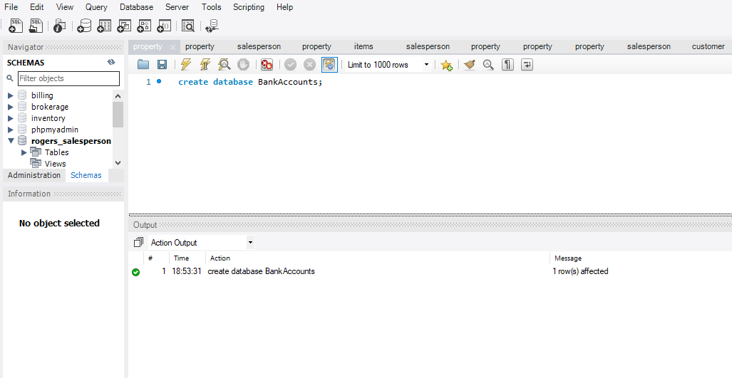

CREATE TABLE `bankaccounts`.`accounts` (

`idAccounts` INT NOT NULL,

`AccountType` VARCHAR(45) NULL,

`AccouHolderName` VARCHAR(45) NULL,

`AccountHolderContact` VARCHAR(45) NULL,

`AccountBalance` DECIMAL NULL,

`AccountSetupDate` DATE NULL,

PRIMARY KEY (`idAccounts`));

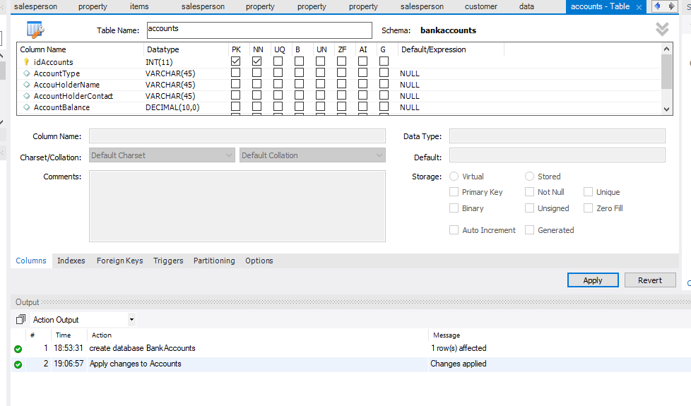

INSERT INTO `bankaccounts`.`accounts` (`idAccounts`, `AccountType`, `AccouHolderName`, `AccountHolderContact`, `AccountBalance`, `AccountSetupDate`) VALUES ('1', 'Checking', 'Paramjeet Kaur', '6523214567', '5000.50', '2018-02-28');

INSERT INTO `bankaccounts`.`accounts` (`idAccounts`, `AccountType`, `AccouHolderName`, `AccountHolderContact`, `AccountBalance`, `AccountSetupDate`) VALUES ('2', 'Saving', 'Ramanpreet Kaur', '5896321456', '3500.00', '2017-03-12');

INSERT INTO `bankaccounts`.`accounts` (`idAccounts`, `AccountType`, `AccouHolderName`, `AccountHolderContact`, `AccountBalance`, `AccountSetupDate`) VALUES ('3', 'Saving', 'Manpreet Singh', '4895621234', '6000.00', '2013-09-22');

INSERT INTO `bankaccounts`.`accounts` (`idAccounts`, `AccountType`, `AccouHolderName`, `AccountHolderContact`, `AccountBalance`, `AccountSetupDate`) VALUES ('4', 'Checking', 'Jobanpreet Singh', '5897451245', '2000.00', '2015-03-23');

INSERT INTO `bankaccounts`.`accounts` (`idAccounts`, `AccountType`, `AccouHolderName`, `AccountHolderContact`, `AccountBalance`, `AccountSetupDate`) VALUES ('5', 'Saving', 'Gundeep Singh', '5897451245', '3518.25', '2014-04-06');

INSERT INTO `bankaccounts`.`accounts` (`idAccounts`, `AccountType`, `AccouHolderName`, `AccountHolderContact`, `AccountBalance`, `AccountSetupDate`) VALUES ('6', 'Saving', 'Harmandeep Singh', '8945612345', '7215.25', '2013-09-23');

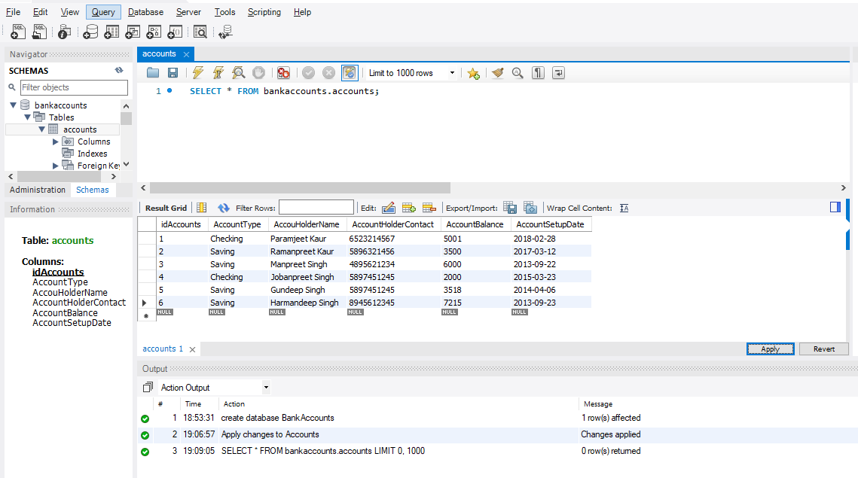

b) Display all the Bank Accounts in your xhtml page View or a JSP page as a table. 20

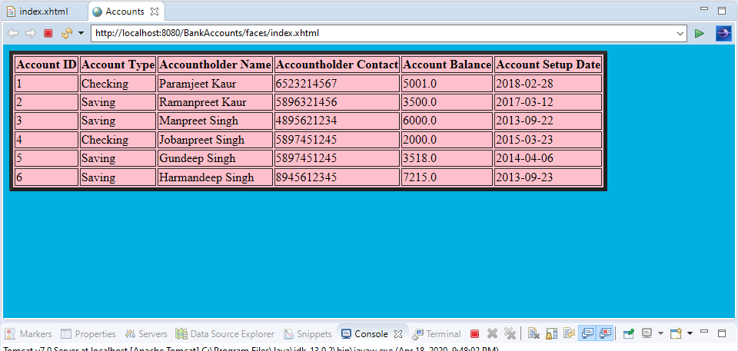

c) Add a new Bank Account in to the database using a button on your view page. 20

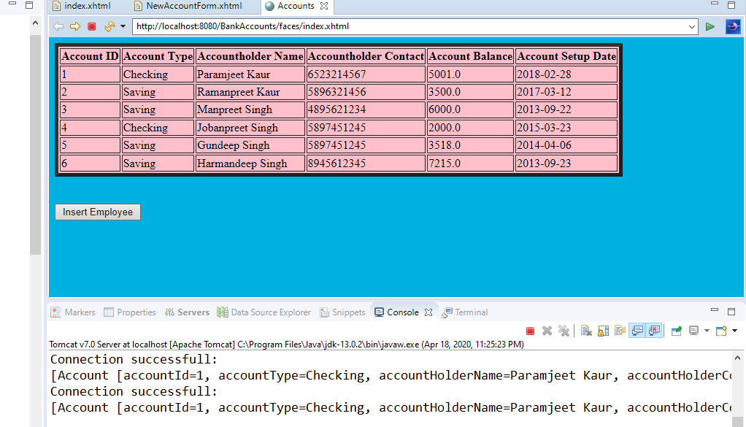

Inserting new Account:

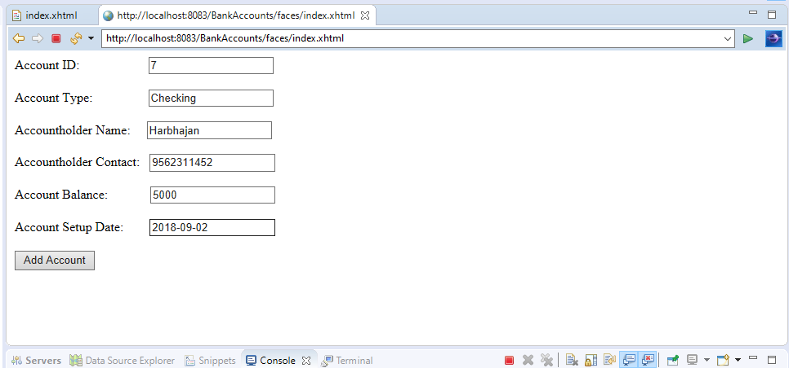

New Account got Inserted:

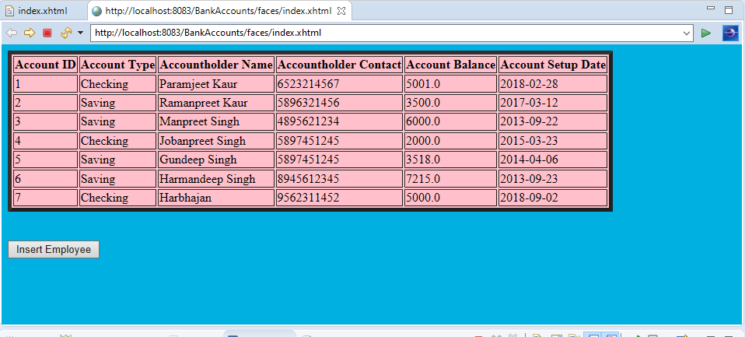

d)Update an existing Bank Account using an Update link on your view page. 20

Before Updating Harbhajan:

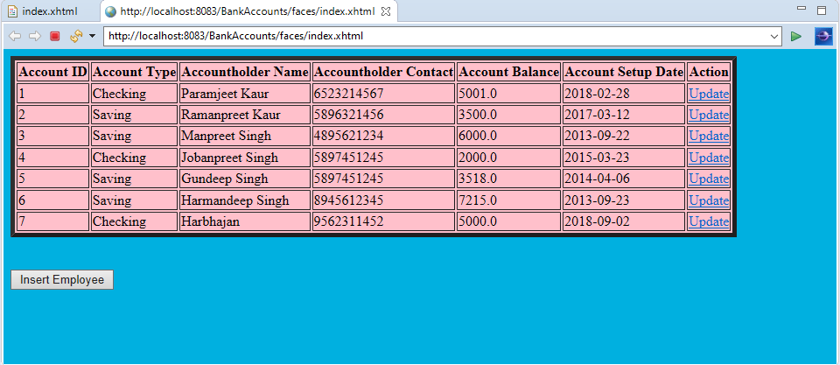

Showing data of Harbhajan on update page:

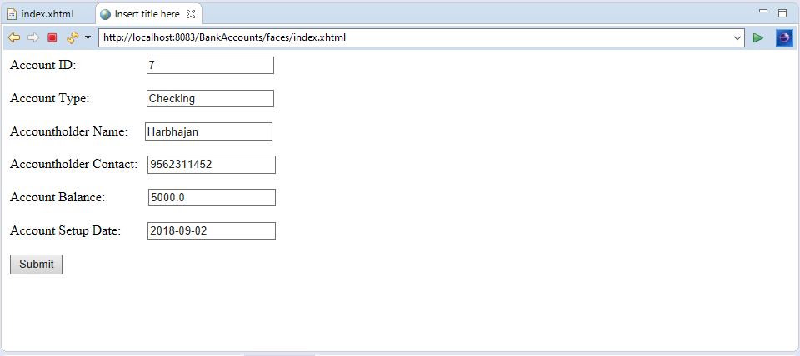

Updated data of Harbhajan:

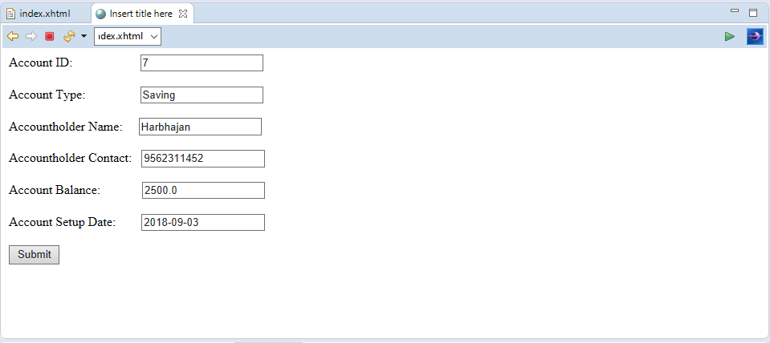

After Updating data of Harbhajan in table:

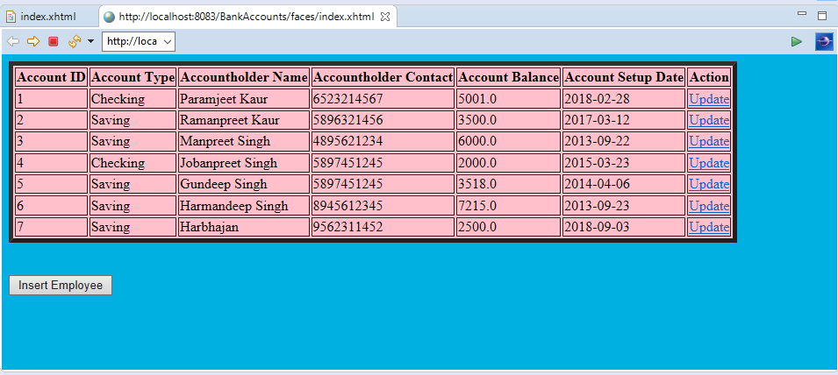

e)Delete a Bank Account using a Delete Link on your view page. 20

Before deleting Harbhajan:

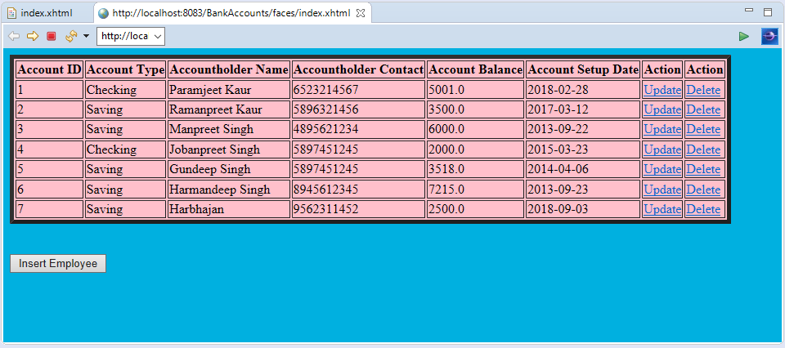

After deleting Harbhajan’s Account:

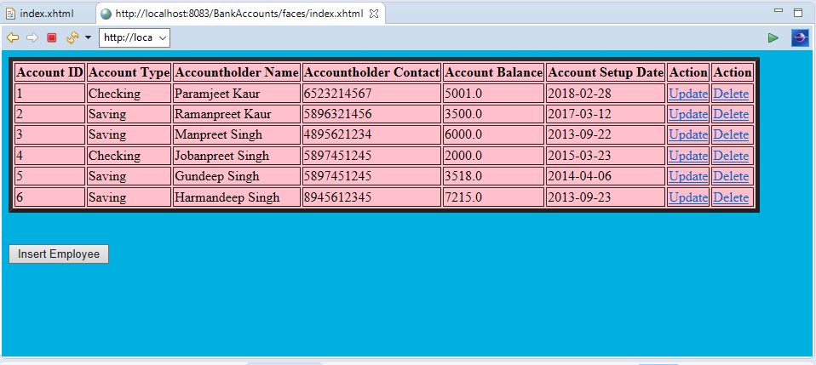

f) Use ManagedBean if using JSF with annotation and create separate DAO class for Crud operations or use a Simple Java Bean as your Model class if using JSPs and Servlets.Try to create separate methods for all crud operations. 10

Managed bean has been used in both model and controller classes.

Model class:

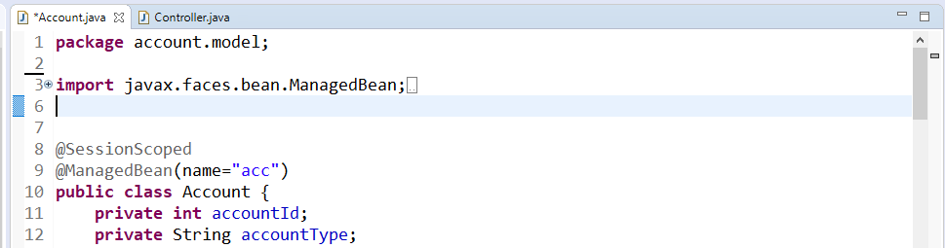

Controller class:

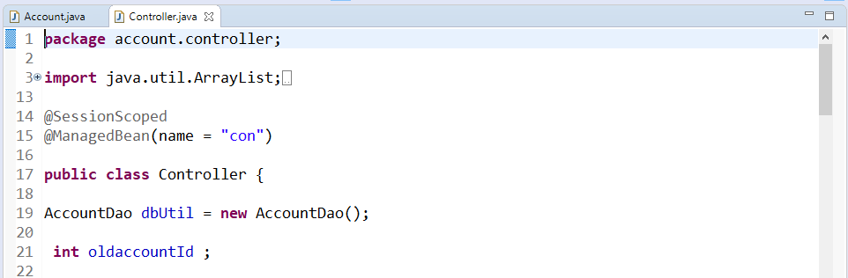

Following is the separate Dao class used in this project with all Crud Operations.

